**OKInvestir Manual**

HE Junyang – SONG Yuzhou

Login page:

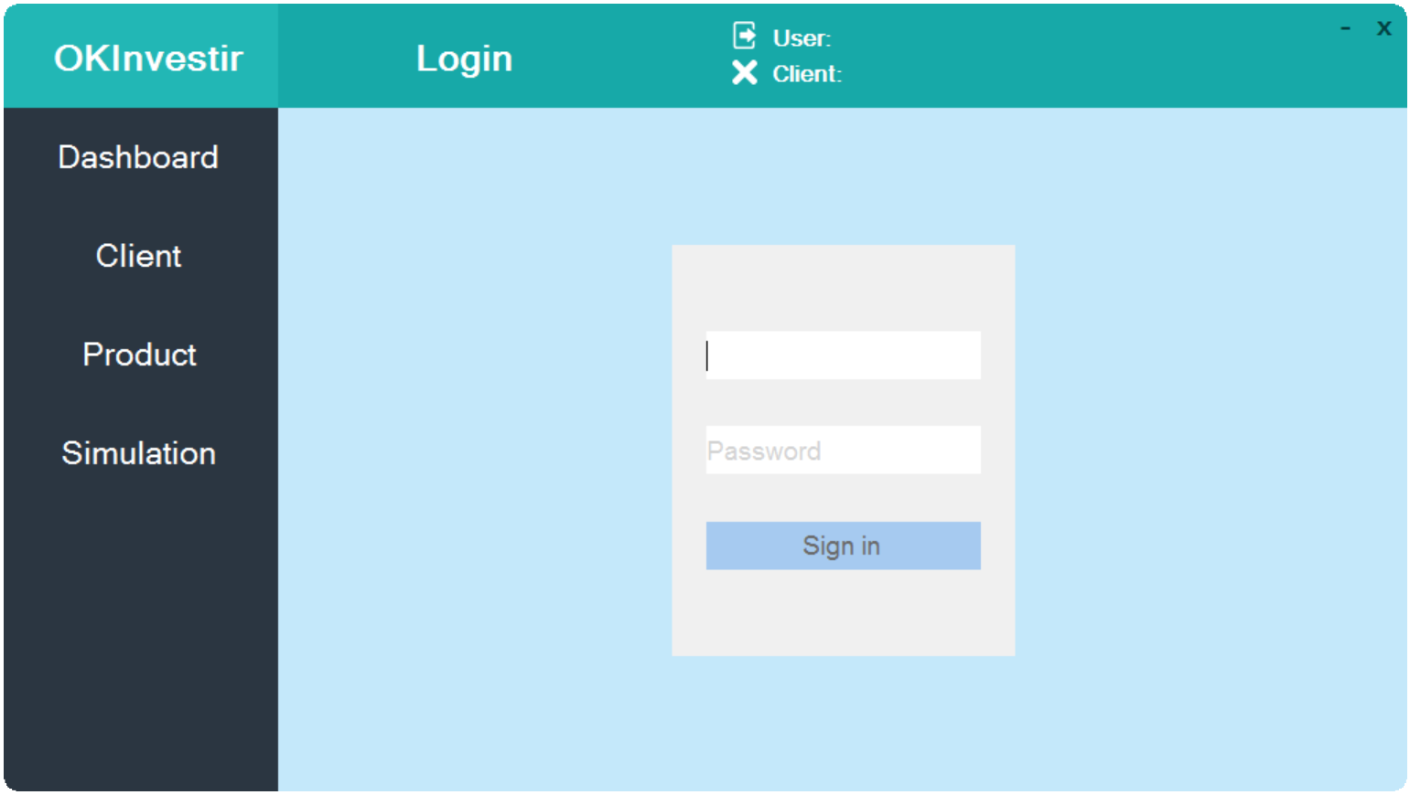

Enter your login and password.

Dashboard:

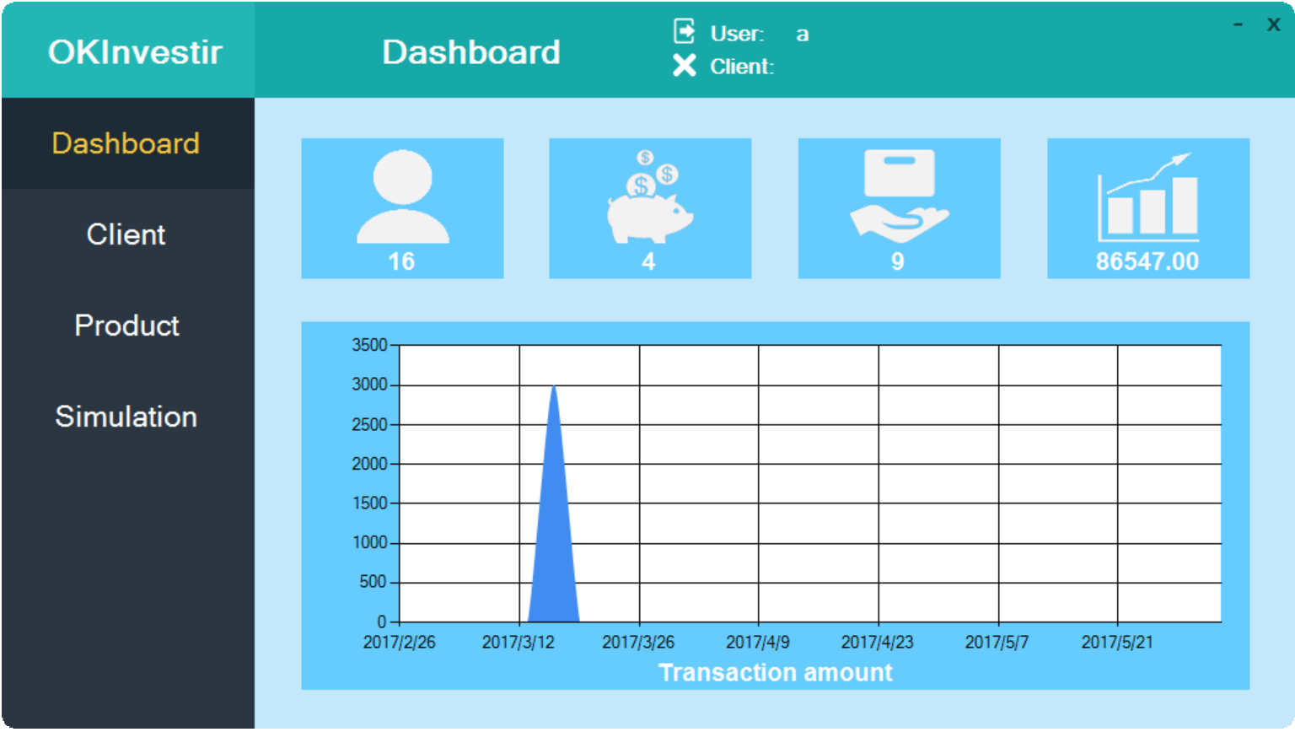

It shows global situation of the application.

Such as total number of users, number of available products, number of product sold, turnover and a chart of transaction history.

Client page:

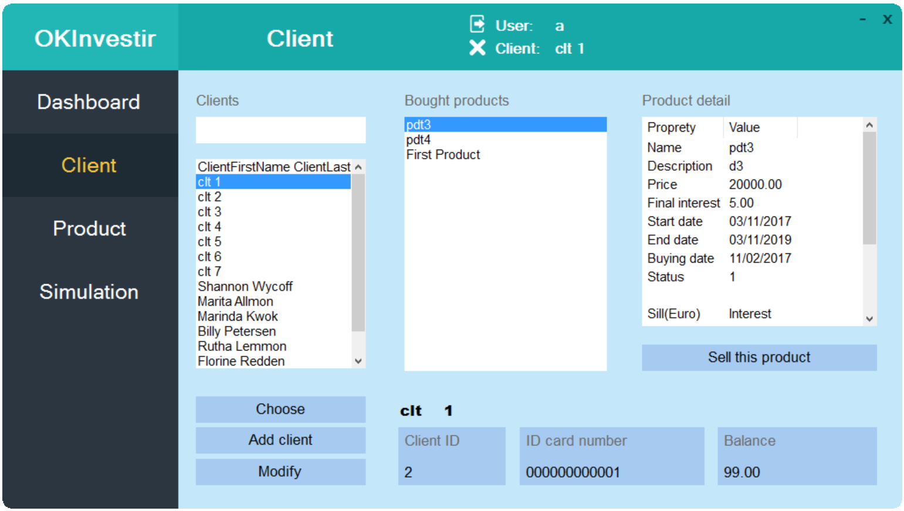

It shows the list of client registered.

You can search a client by his name. Click on a client’s name to consult his information such as ID, card number, balance and bought product list. Click on a bought product to show its details.

You can click on Add Client to create a new client.

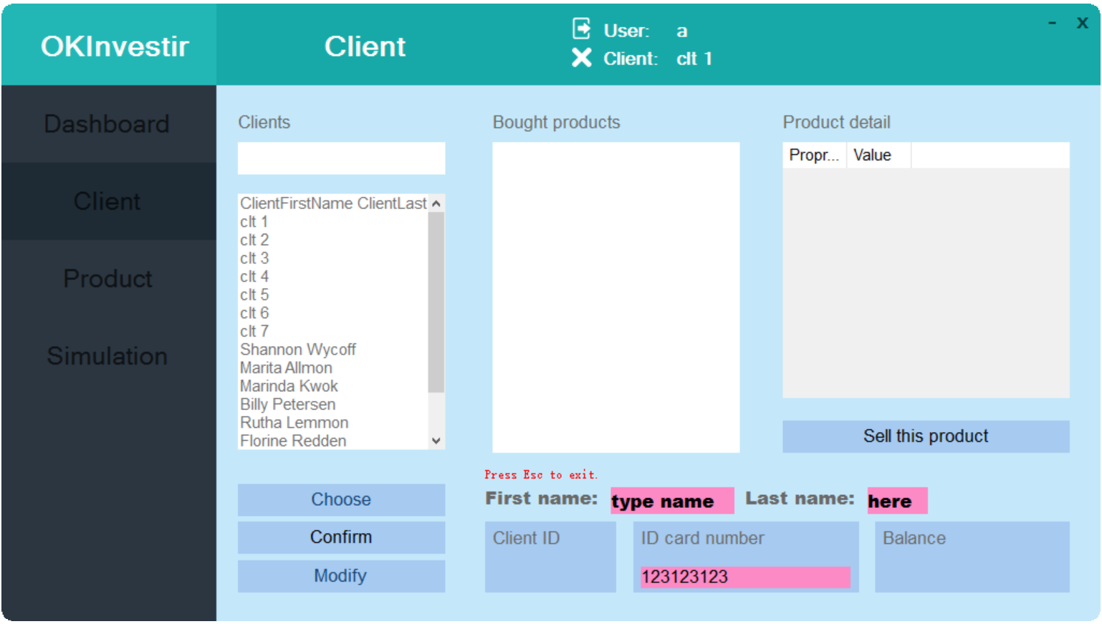

Click on confirm to save, or press Esc to exit.

You can select a bought product and click on Sell this product to sell it before the end day of the holding period.

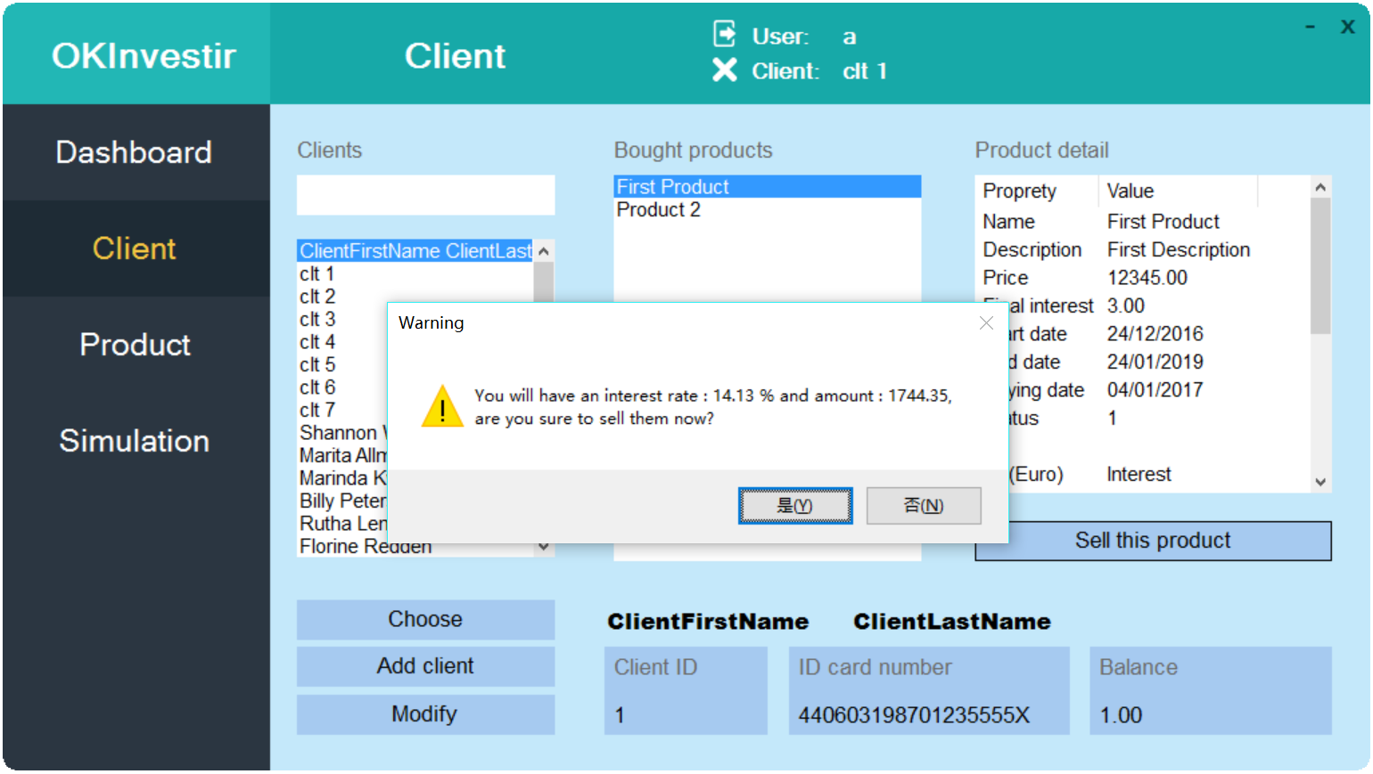

You can click on Choose to select a client for a simulation.

The header of the application will show the user logged in and the client selected.

Product page:

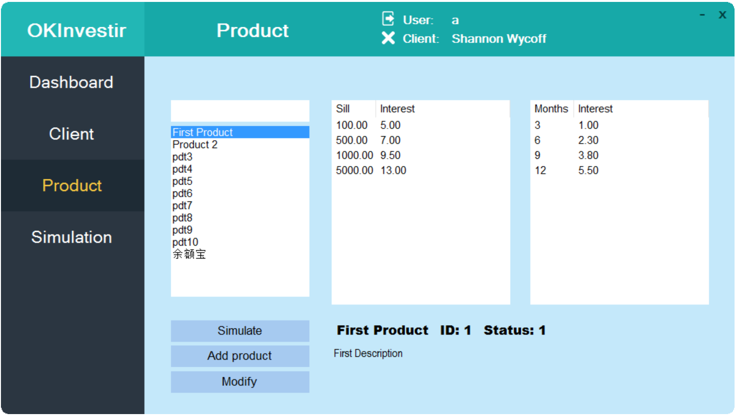

First column shows the list of product available.

Second column shows the sill-interest of the selected product.

Third column shows the time-interest of the select product.

Click on Add product to create a new product or click on Modify to modify the select product.

Create/Modify product page:

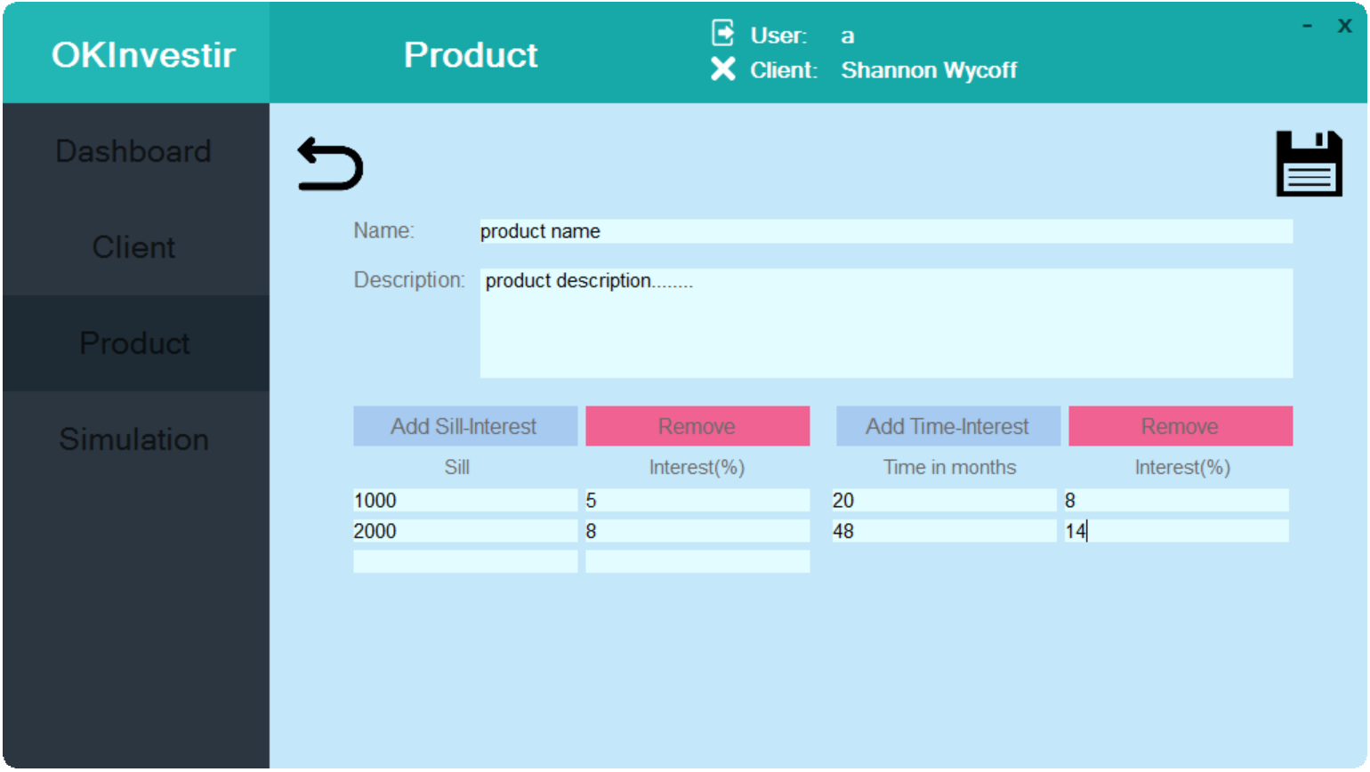

Enter the information of a product

Each row of the first two columns is the sill-interest information of the product.

Each row of the next two columns is the time-interest information of the product.

Click on Save icon to save or click on return icon to abandon modification.

Click on Add Sill-interest or Add Time-interest to add a row.

Click on remove to remove the last row.

You can click on the Simulate button to go to the simulation page of the selected product.

Simulation page:

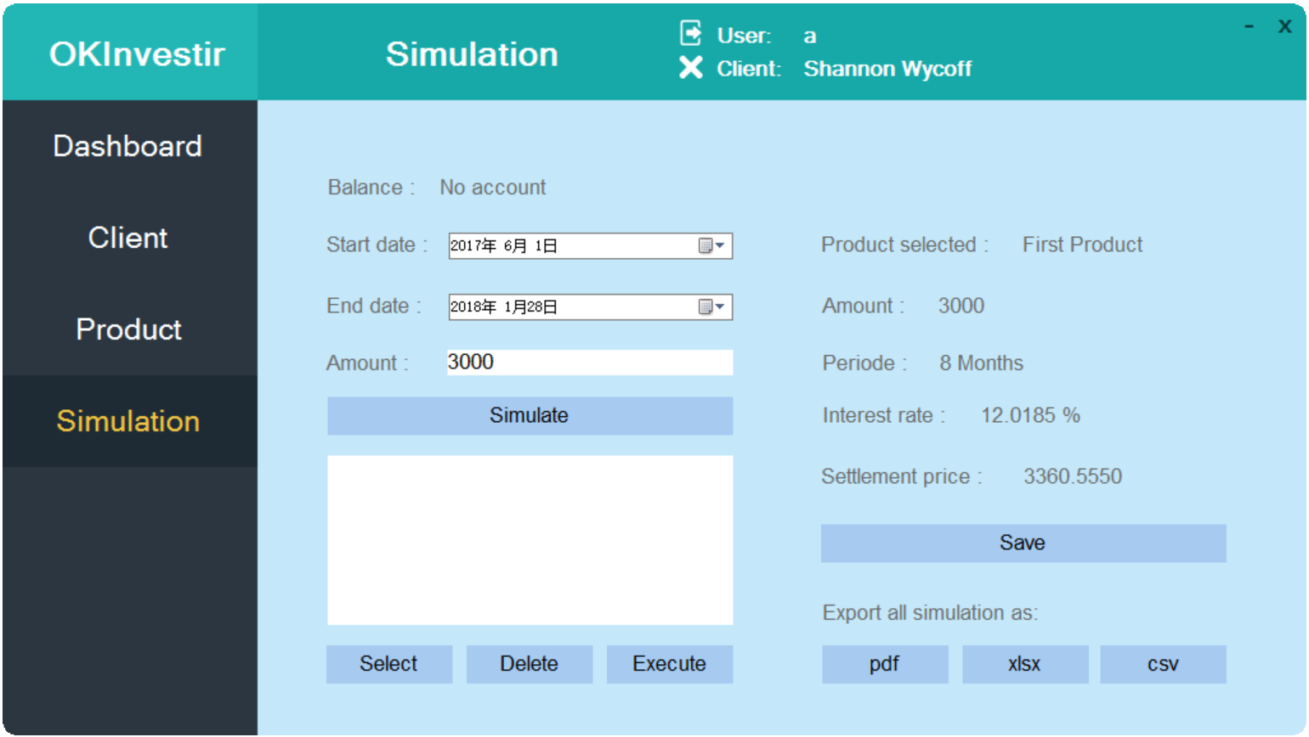

Enter Start/End date and an amount, and click on Simulate to calculate the result.

You can change the parameters to simulate again.

Click on Save button to save the simulation result.

The list of simulation result saved:

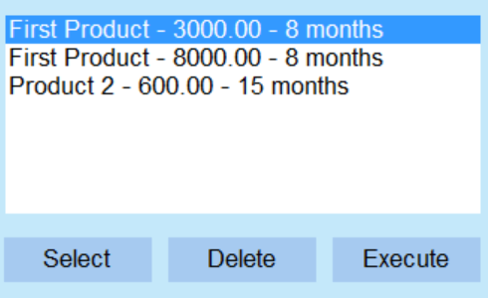

Click on Select to load a save simulation result.

Click on Delete to remove a simulation.

Click on Execute to buy the product with the parameter.

You can export the list of simulation result by clicking on the following buttons:

